Specific facilities provided for women in terms of:
a. Safety and security
b. Counselling
c. Common Rooms
Dharmendrasinhji Arts College, Rajkot shows gender sensitivity in providing facilities such as:

1. Safety and security
Safety norms are strictly followed by Dharmendrasinhji Arts College, Rajkot.
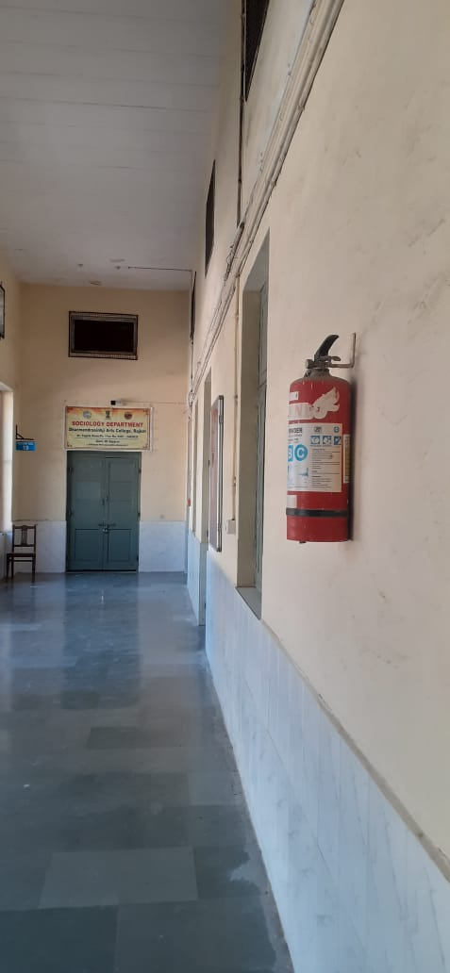 Fire Extinguisher

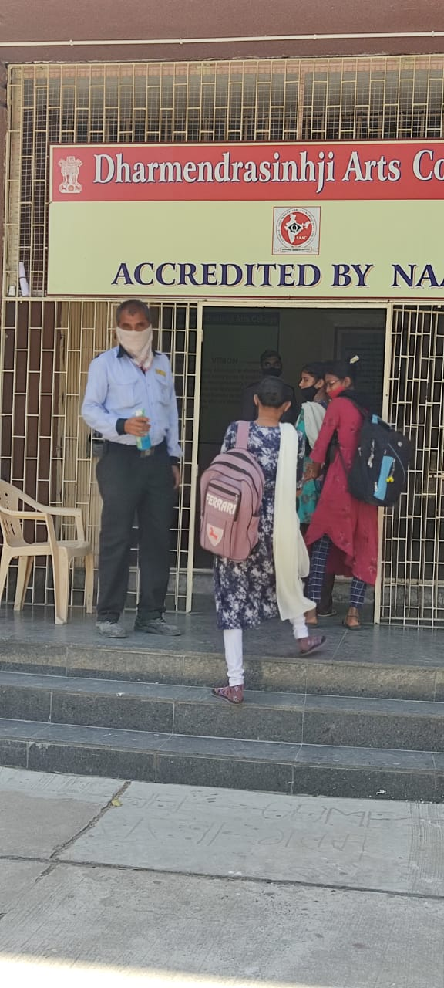
Safety and Security
Safety and security of girls is monitored on the corridors of both the floors of the building, classrooms, playground and library.
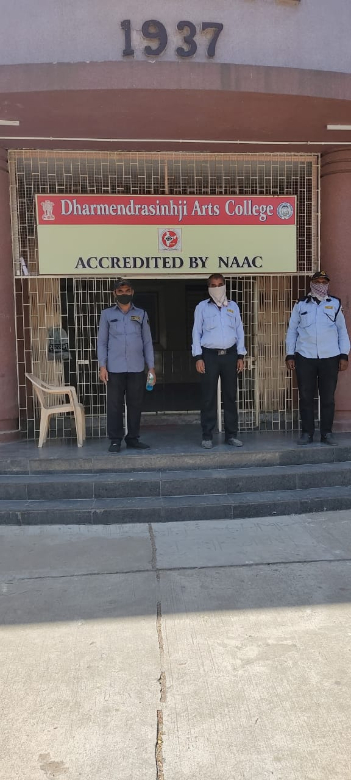
Security Personnel at the entrance of the college
There are 5 security personnel who safeguard the entire campus. Girl students and all the other females are highly secured under the existing security system.
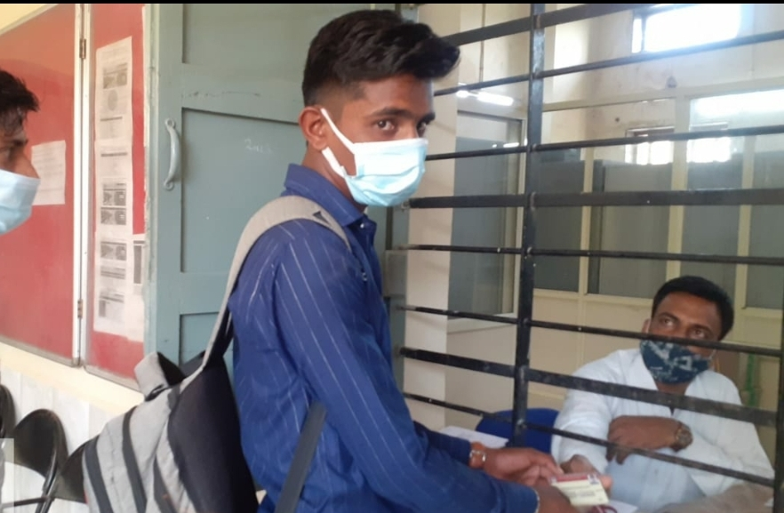
ID Cards given to the students
ID cards are issued to the students and staff to prevent the entry of outsiders into the college premises.

2. Counselling:
Our college has formed The Grievance Redressal and Appraisal Committee to ensure a fair, impartial and consistent way for redressal of various issues faced in the college.
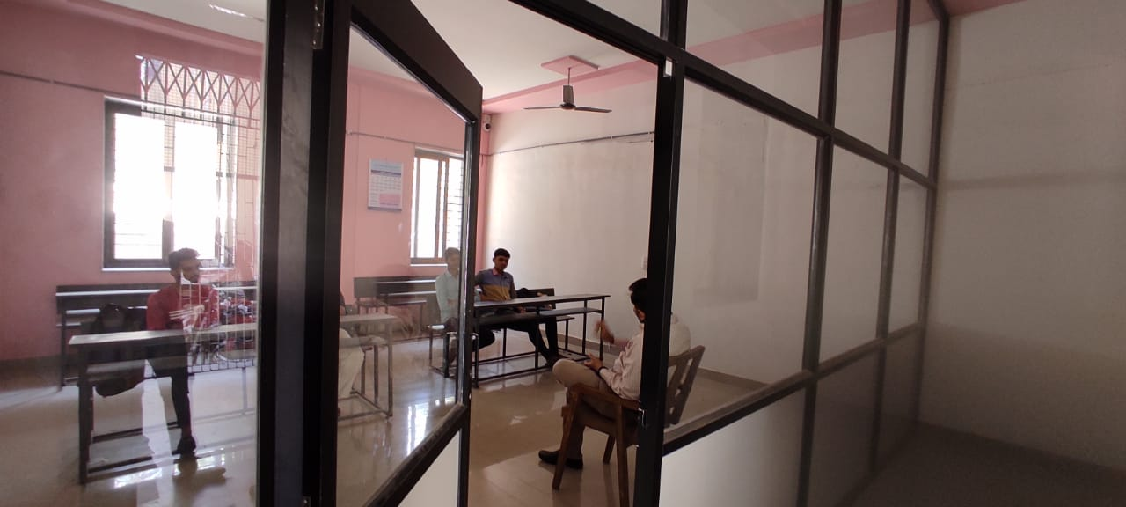

Counselling of Students
Our college has implemented a Mentor System. The prime objective to implement a Mentor System is to keep the effective mentoring and welfare of the students; a group(main subject) 40 students are attached to a faculty member preferably who engages the particular class.
This method improves the bond between students and mentors. Special focus is paid to slow learners identified through counselling.
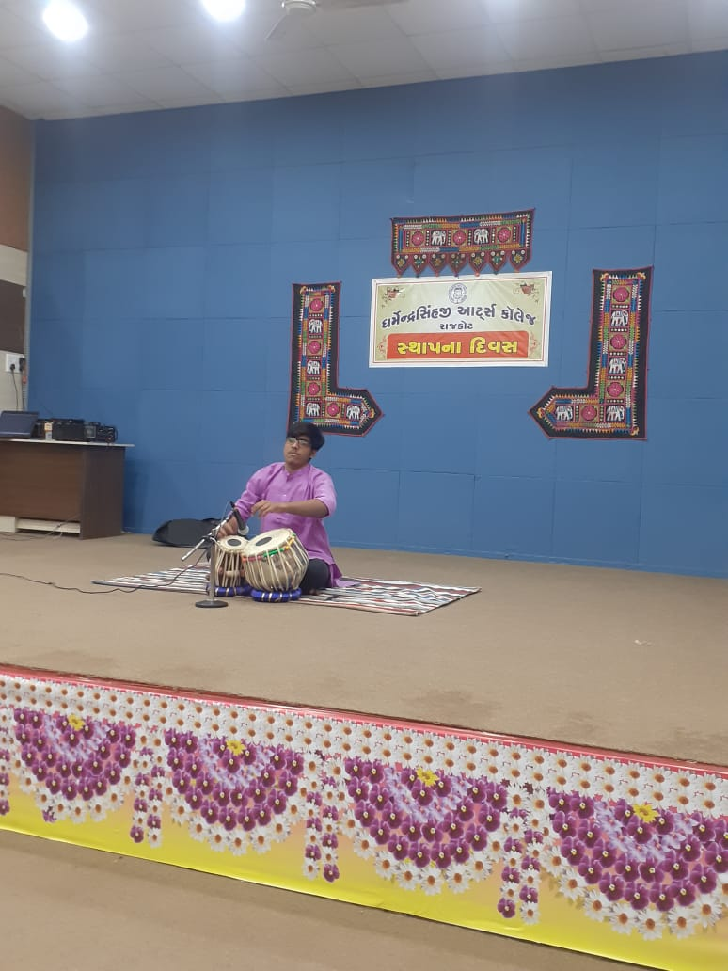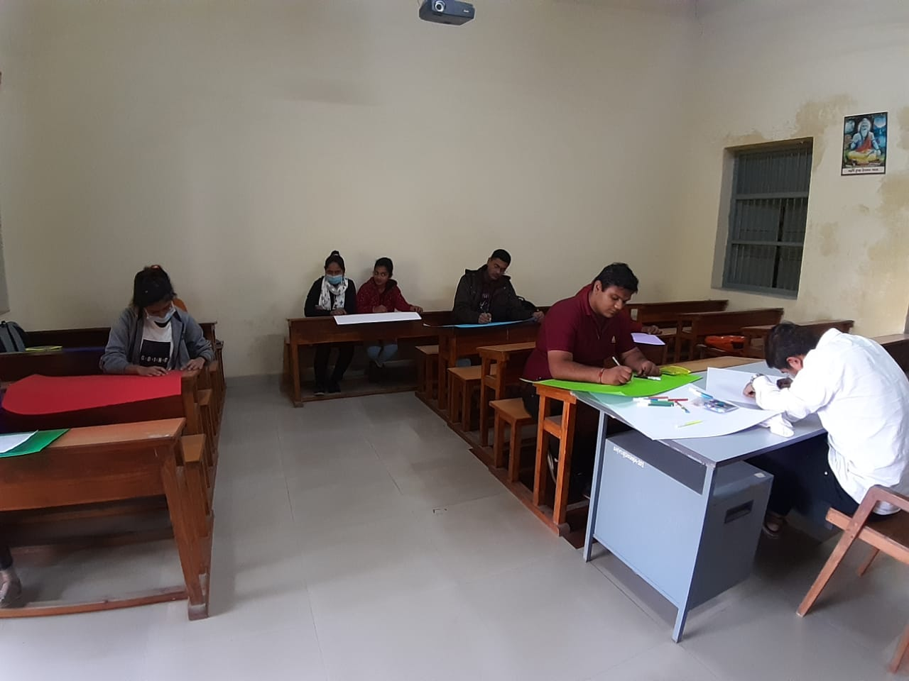
Students are encouraged to participate in co-curricular and
extracurricular activities.
The importance is given for overall development of students through bridge courses, co-curricular and extra-curricular activities.
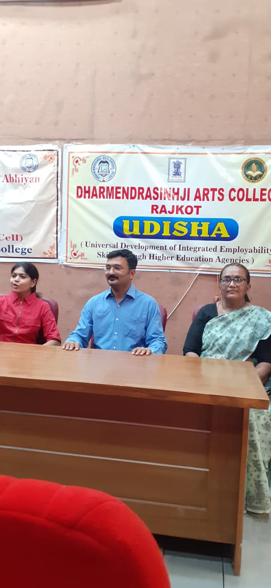
Dr. Rushiraj Waghela, an Assistant Professor of English from Thakor Shree Mulavaji Arts College, Kotada Sagani was invited on 20/03/2021 for Career Counselling Session
Career Counselling Talks are also organised every year in college for undergraduates’ further progress. In year 2020, the career Counselling talks were digitally organised,
3. Common room
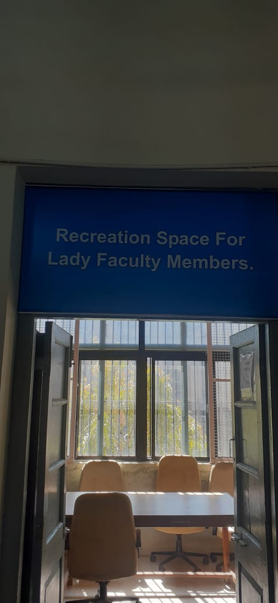
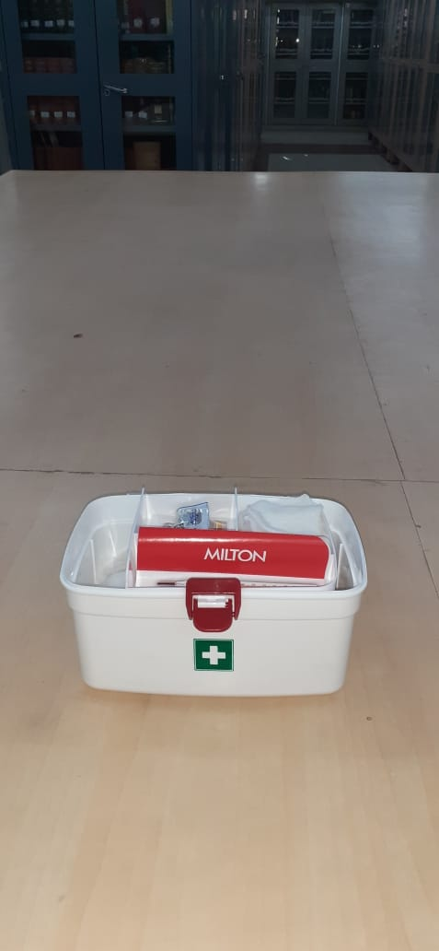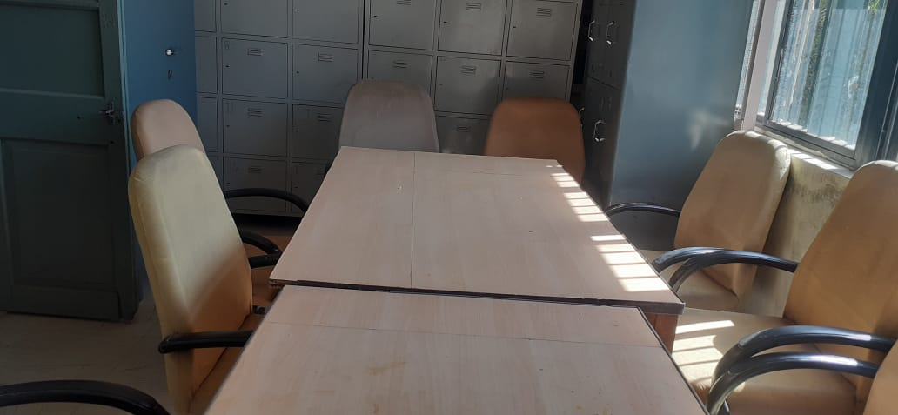
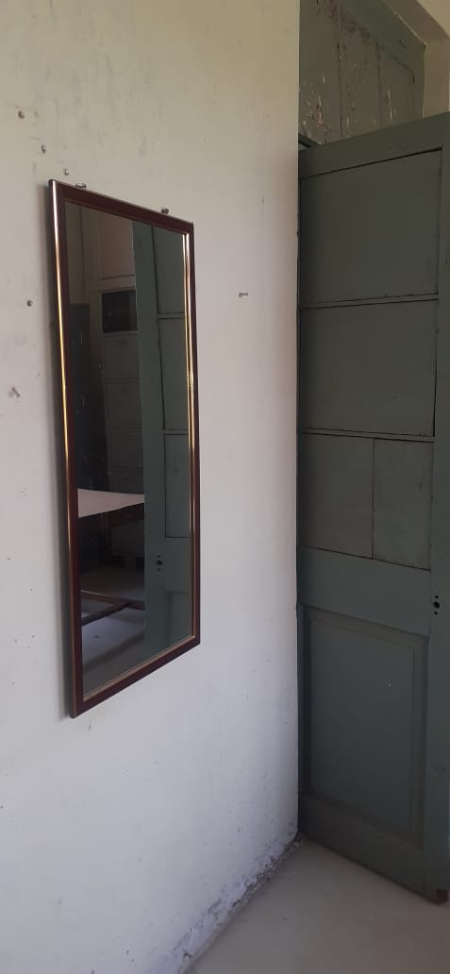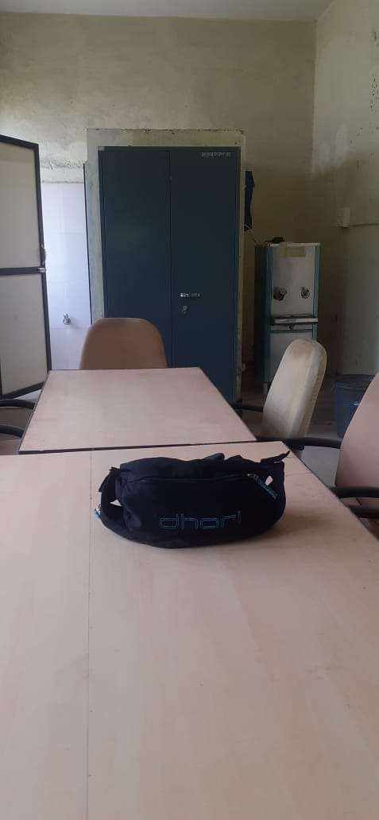
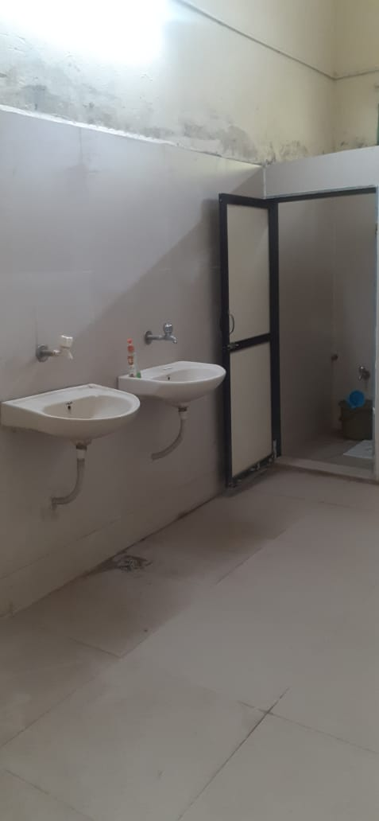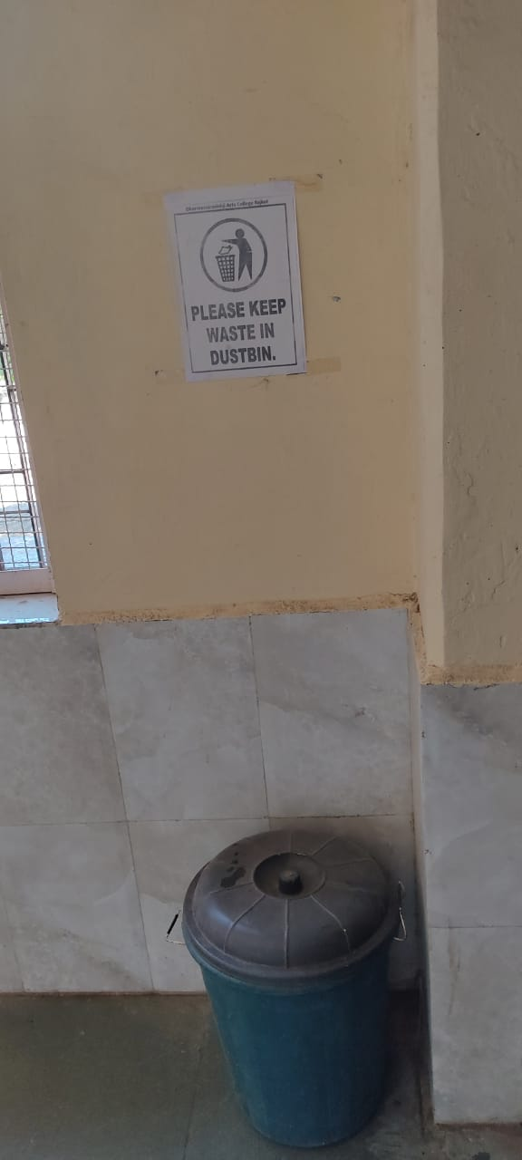
Separate Common room is provided for girls. A Girls’ Room is provided with necessary facilities like first aid box, rest room, cots, mirror, chair, table, washroom, washbasin, dustbin etc.

